X86 MEMORY MANAGEMENT

x86 processors manage memory differently depending on the mode of operation. These modes determine how programs access memory and system hardware.

I. Real-Address Mode

* The simplest mode.
* Memory limit: **1 MB** (from 00000h to FFFFFh).
* Only **one program runs at a time**, but the processor can pause it briefly to handle hardware requests called **interrupts**.
* Programs can access **any memory location**, including memory mapped to hardware.
* Operating systems using this mode: **MS-DOS**.
* Windows 95 and 98 can boot into this mode.

**Key points:**

* No protection between programs.
* Simple but limited in memory and multitasking.

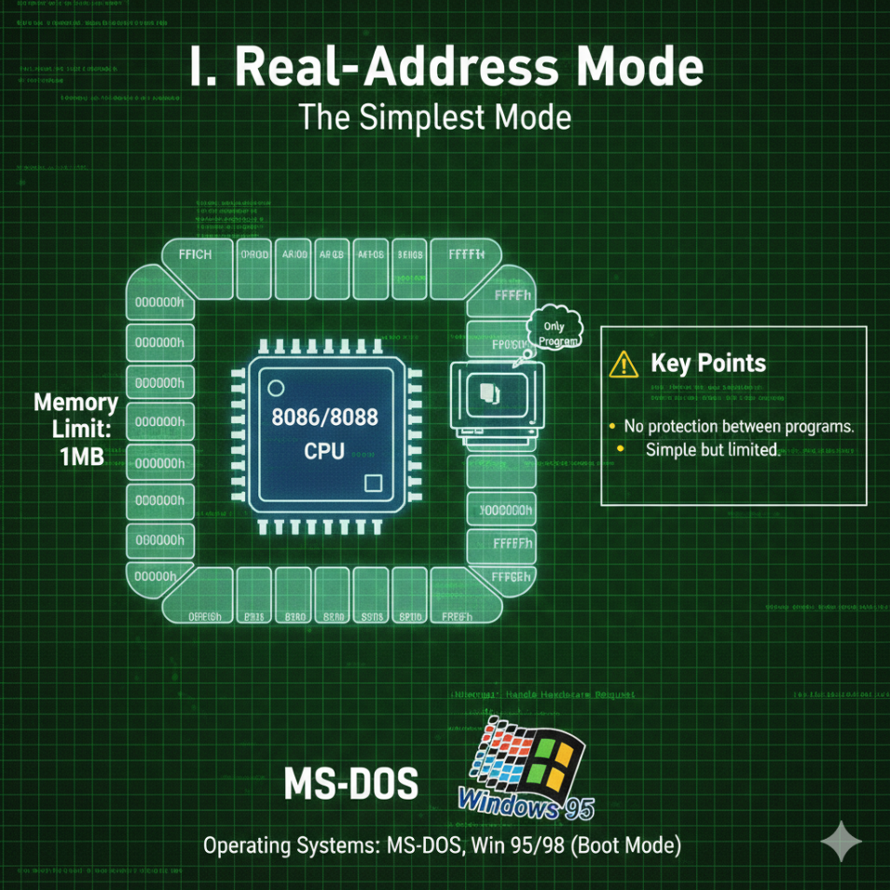

II. Protected Mode

* Allows multiple programs to run **simultaneously**.
* Each program gets **up to 4 GB of memory**, isolated from other programs.
* Prevents accidental access to other program’s code or data.
* Operating systems using this mode: **Windows NT, 2000, XP, Linux**.

Key Points:

* Memory protection prevents crashes caused by one program affecting others.
* Essential for modern multitasking operating systems.

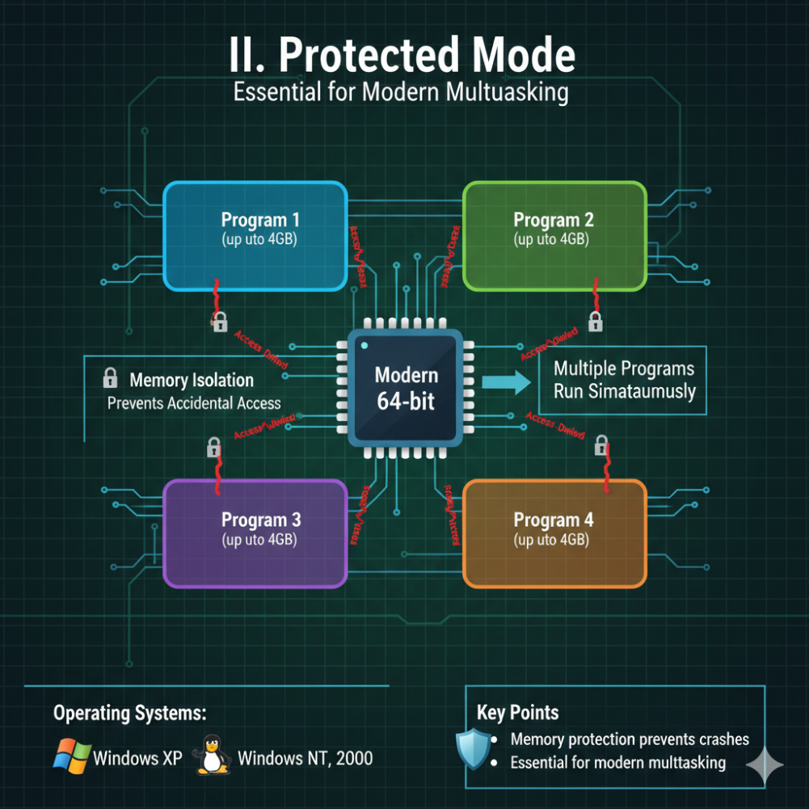

III. Virtual-8086 Mode

* Runs in **protected mode** but creates a **virtual 8086 machine**.
* Each virtual machine has **1 MB memory**, simulating a real-address mode environment.
* Allows multiple DOS-like windows to run safely.
* Operating systems using this feature: **Windows NT, 2000, XP**.

**Limitations:**Programs that directly access hardware may **not work properly** in this mode.

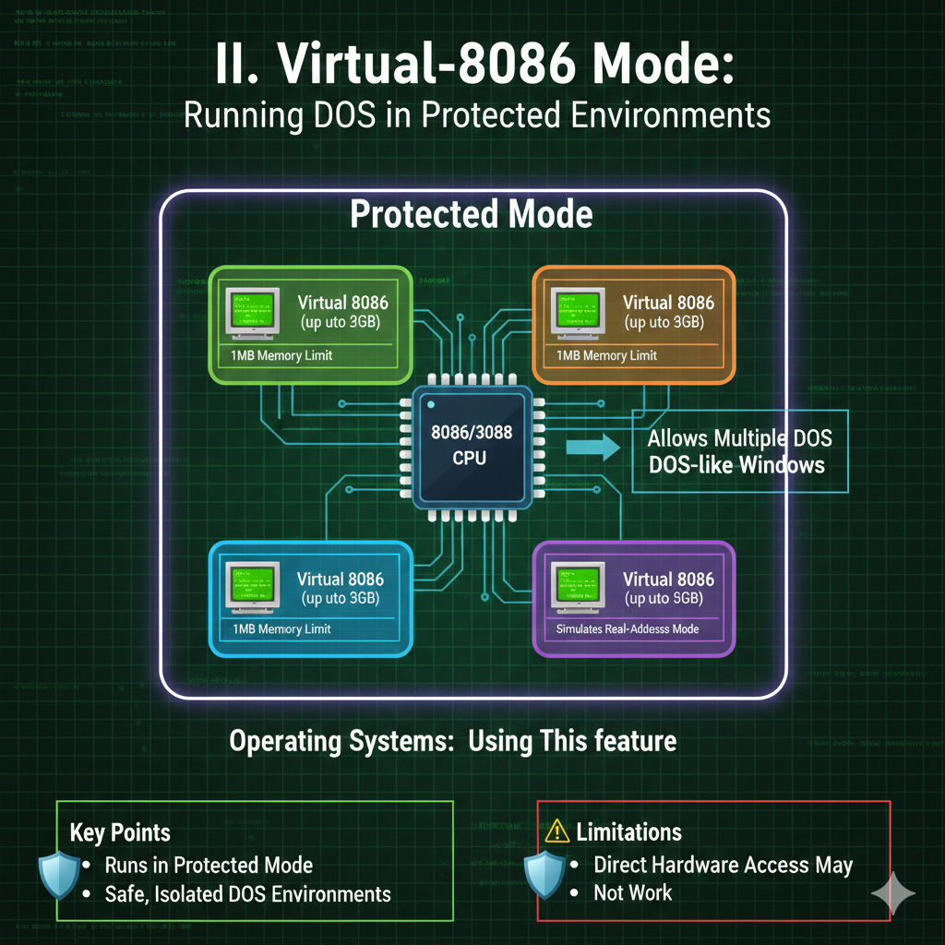

X86-64 PROCESSORS VS X86 PROCESSORS

x86-64 is an **extension** of the x86 instruction set that supports **64-bit computing**.

I. Main Features Of x86-64

* Uses **64-bit addresses**, allowing a huge virtual memory space: 2^64 bytes.
* Physical memory support: **up to 256 TB**.
* **16 general-purpose registers** (8 more than x86).
* **64-bit instruction operands**.
* Does **not support** 16-bit real mode or virtual-8086 mode in native 64-bit mode.
* Backward compatible with x86 instructions.

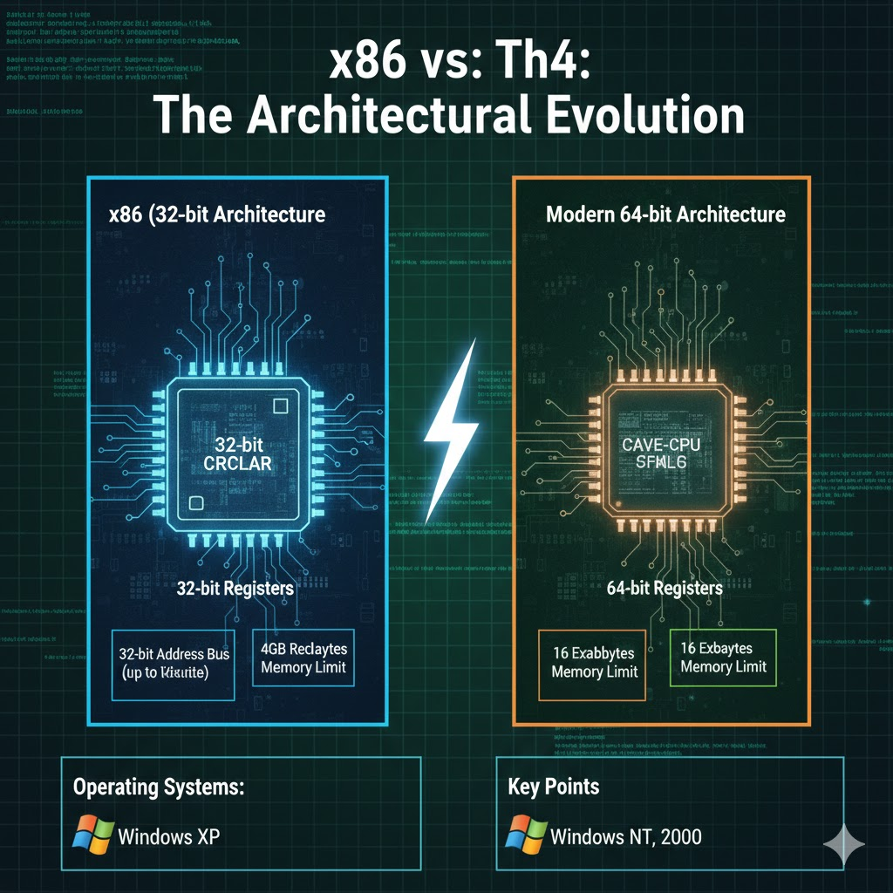

II. Modes In Intel 64 Architecture

**Compatibility Mode**: Runs older **16-bit and 32-bit programs** without recompiling.

**64-bit Mode**: Native mode for modern 64-bit applications.

III. Registers

In modern 64-bit CPUs, there are several types of registers you need to know, as we’ve discussed in the previous chapter.

There are **16 general-purpose registers**, each 64 bits wide, used for most calculations, addressing, and data storage.

The CPU also has **8 floating-point registers**, each 80 bits wide, which store floating-point numbers and intermediate results for precise math.

The **RFLAGS register** is 64 bits, holding status flags that report the results of operations and control CPU behavior.

Only the lower 32 bits are used in most instructions. The **RIP register** is the 64-bit instruction pointer, keeping track of the next instruction to execute.

For multimedia and SIMD tasks, there are:

* **8 MMX registers** (64-bit), mostly legacy
* **16 XMM registers** (128-bit), used for SSE, AVX, and other SIMD extensions

The **REX prefix** in 64-bit mode allows instructions to access the full 64-bit registers.

Some important notes about operands and sizes:

* Registers can operate on **8, 16, 32, or 64-bit values**
* In 64-bit mode, the **default operand size is 32-bit**, unless you override it with prefixes or instruction modifiers

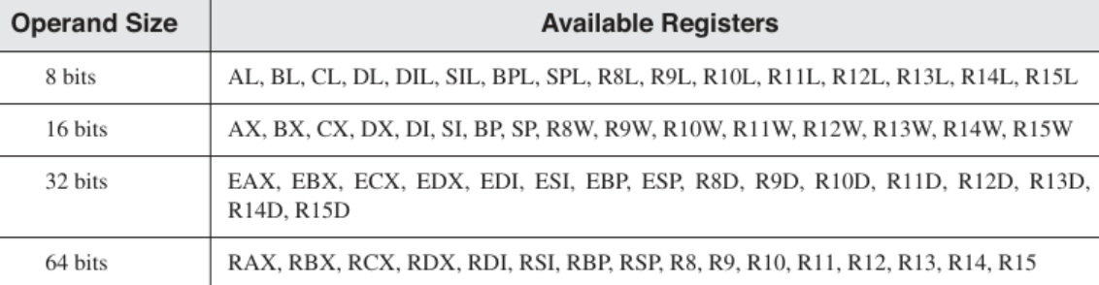

64-BIT REGISTER QUIRKS

I. THE REX PREFIX LIMITATION

In **64-bit mode** (also called **Long Mode**), the CPU introduces **new registers** (R8–R15 and their byte versions) but also enforces a strict rule when accessing **byte-sized registers**.

There’s an important rule when working with registers in modern x86-64 CPUs.

You **cannot mix the old high-byte registers**—AH, BH, CH, or DH—with the **new low-byte registers**, like SIL, DIL, BPL, SPL, or R8B through R15B, in the same instruction.

In other words, a single instruction can’t operate on both an old high-byte register and one of the new low-byte registers at the same time.

This is just a hardware limitation, so you have to plan your instructions accordingly.

Think of it like trying to mix oil and water—they exist in the same CPU, but they **don’t combine in a single operation**.

**Why?**

* To access the new registers, instructions use a special **prefix code** called **REX**.
* The CPU hardware is designed so that **REX cannot coexist with legacy high-byte registers** in the same instruction.
* Trying to mix them will **cause an invalid instruction** error.

**Examples (HTML 0017 in this folder):**



**Key Point:**

* Any instruction that involves **R8–R15 byte registers** must use the **REX prefix**.
* If you try to include a **high-byte legacy register**, the instruction will **fail to decode**.

**Tip for programmers:**

* Stick to **low-byte registers** (AL, BL, CL, DL, SIL, DIL, BPL, SPL, R8B–R15B) when mixing old and new registers in 64-bit mode.

II. RFLAGS: The 64-Bit Status Register

In **32-bit mode**, we had **EFLAGS** (32 bits) to track the CPU status. In **64-bit mode**, it is upgraded to **RFLAGS** (64 bits).

**Structure of RFLAGS:**

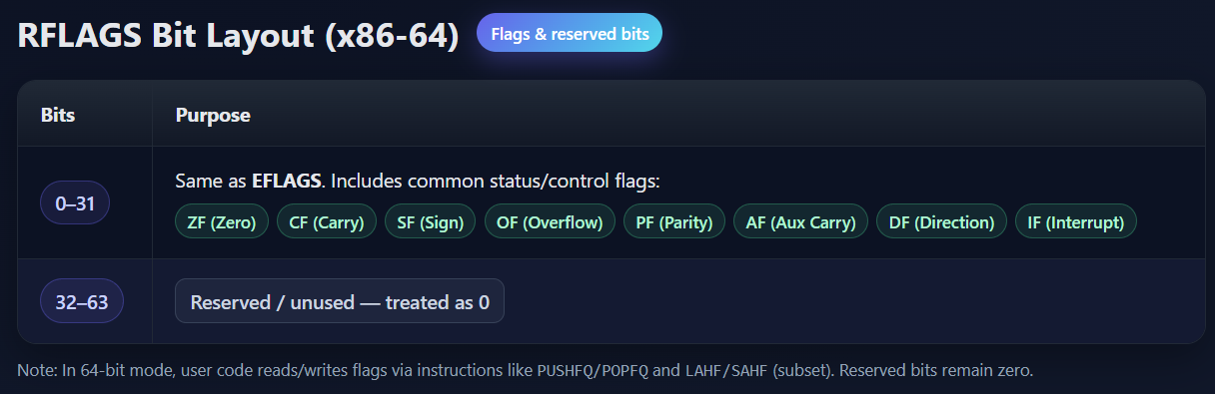

**What this means:**

* **All your old logic still works** in 64-bit mode.
* Instructions like JZ (Jump if Zero) or JC (Jump if Carry) check the **exact same bit in RFLAGS** as in EFLAGS.
* No need to learn new flag bits when writing or reverse engineering 64-bit code.

**Why it matters:**

* Even though the register is now 64 bits, **all conditional logic uses the lower 32 bits**.
* Malware analysts and assembly programmers can **reuse 32-bit knowledge** without worrying about new flags.

**Practical Example:**

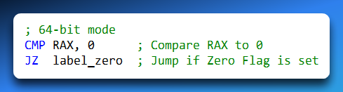

The JZ instruction checks **ZF**, which is still bit 6 in **RFLAGS**, exactly like in 32-bit mode.

Upper 32 bits of RFLAGS are **ignored**, so nothing changes in logic.

**Tip:** Think of RFLAGS as **EFLAGS extended to 64 bits**. The extra bits don’t affect most programming or debugging tasks.

✅ Expanded Notes Summary:

1. **REX prefix** allows access to new registers but prevents mixing with **high-byte legacy registers**.
2. **RFLAGS** is a 64-bit version of EFLAGS; **logic flags remain in the lower 32 bits**.
3. Conditional instructions like JZ, JC, etc., work exactly the same in 32-bit and 64-bit modes.
4. Assembly programmers can **reuse 32-bit concepts** when working in 64-bit mode.

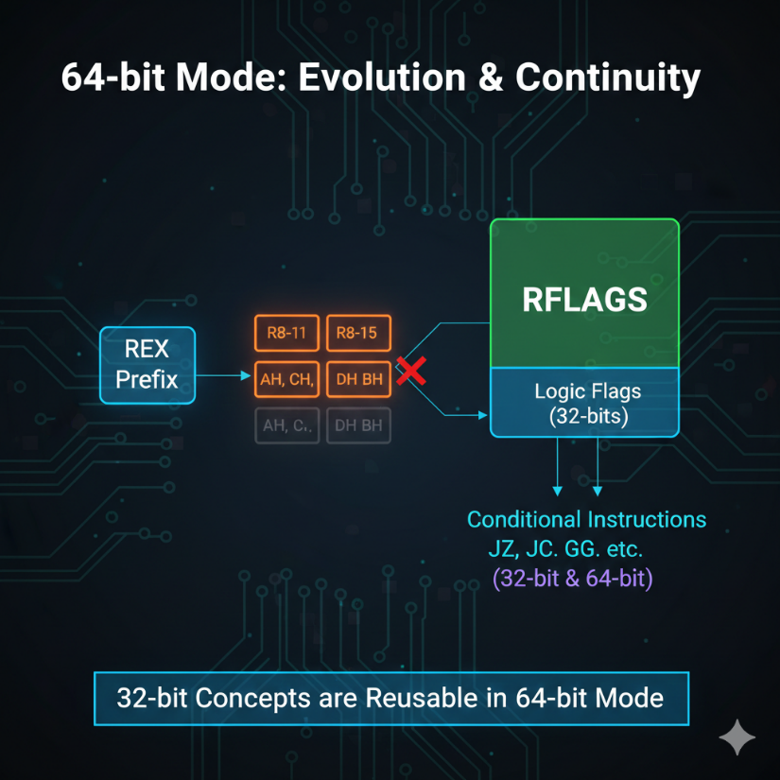

x86 HARDWARE ARCHITECTURE

4.0 Introduction: The Anatomy of the Machine

If the CPU is the "Brain," the Hardware Architecture is the "Body." You cannot become a master programmer or reverse engineer without understanding the physical terrain your code travels through.

4.1 The Motherboard: The Central Nervous System

The **Motherboard** (or Mainboard) is a complex printed circuit board (PCB) that acts as the hub for all communication.

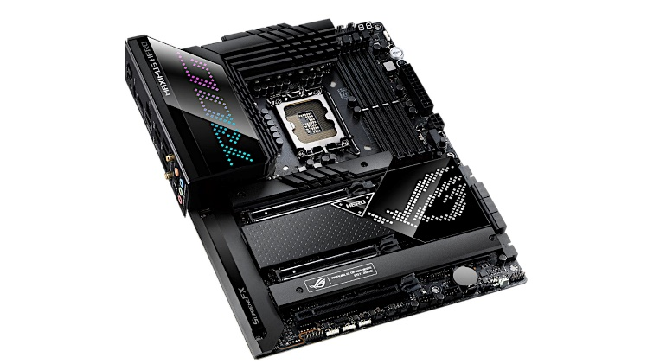 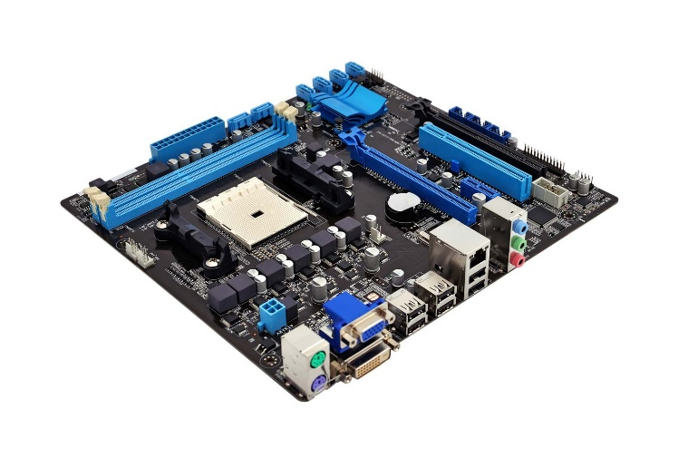

I. The Bus

The "Bus" isn’t a vehicle—it’s a network of microscopic copper wires etched onto the motherboard. Think of it as the **highway system** for your computer. Data travels along the bus between different components of the system. If a bus is “64 bits wide,” imagine a highway with 64 lanes—**64 bits of data can travel at the same time**.

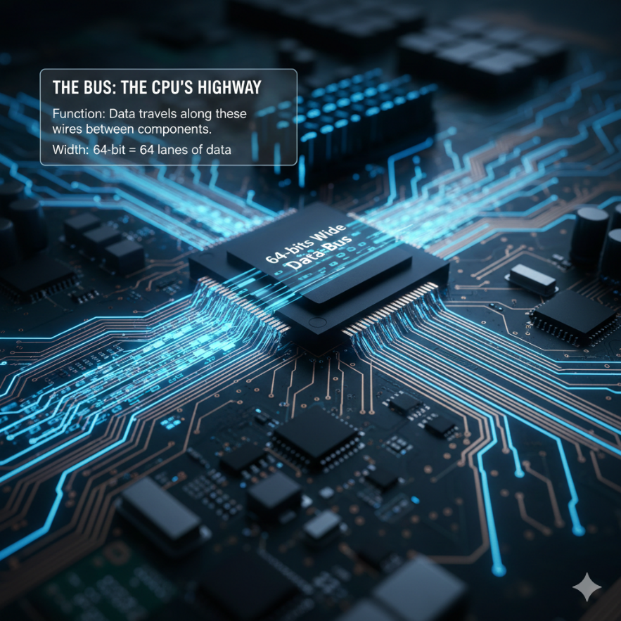

II. Key Components of the Motherboard

**CPU Socket – The Throne:** This is where the processor lives. Different CPUs require different socket types (e.g., **LGA 1700** for Intel, **AM5** for AMD).

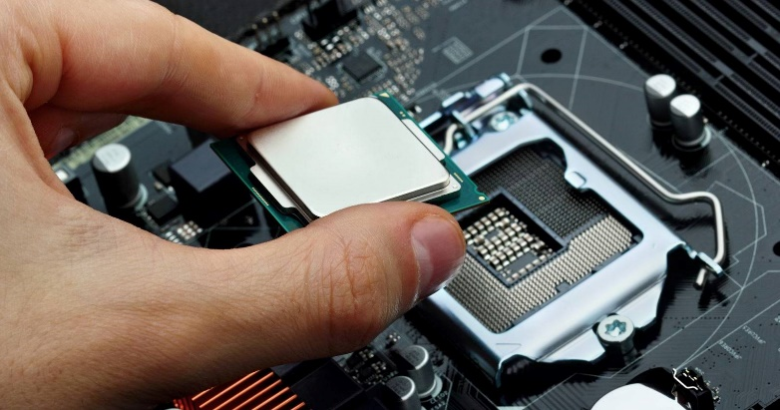

**Memory Slots (DIMM):** These hold the RAM sticks, which provide fast, temporary storage for the CPU.

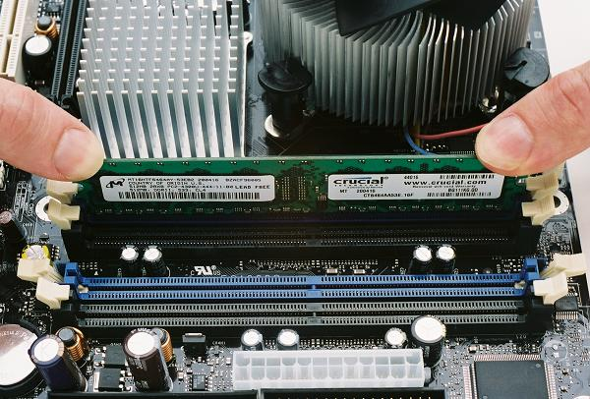

**Expansion Slots (PCIe):** Think of these as parking spots for high-speed add-ons, like graphics cards (GPUs), WiFi cards, or other peripherals.

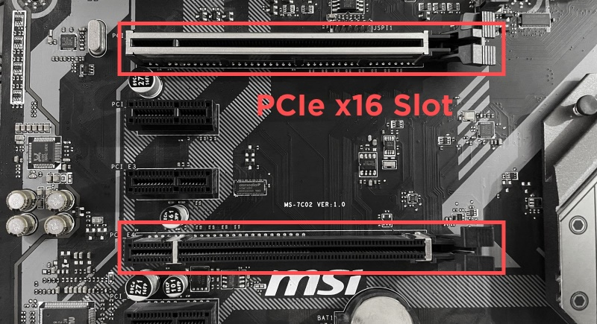

**BIOS Chip:** A non-volatile chip containing the startup code that helps your computer boot and initialize hardware.

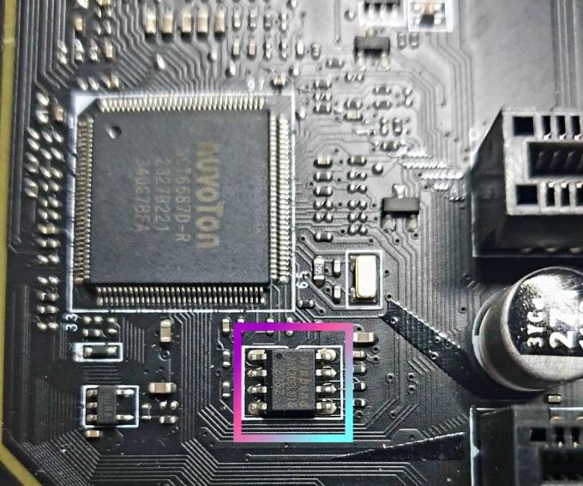

4.2 THE CHIPSET: The Traffic Controllers

The CPU is too fast and too important to talk to a slow USB keyboard directly. It delegates this work to the **Chipset**.

I. The Memory Controller Hub (MCH)

Historically called the **Northbridge**.

**Job:** High-speed logistics. It connects the CPU to the **RAM** and the **Graphics Card**.

**Performance:** Intel’s "Fast Memory Access" technology allows the MCH to look ahead at memory requests and reorder them for maximum speed (like a chef arranging orders to cook efficiently).

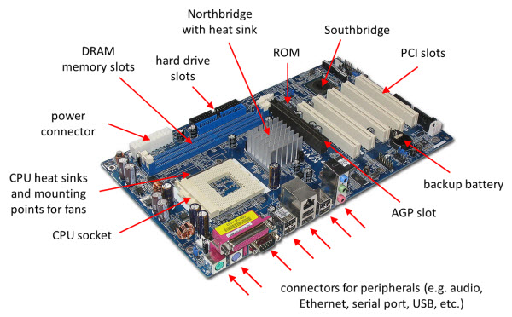

*Modern Note:* In modern CPUs (i3/i5/i7/Ryzen), the MCH is moved *inside* the CPU chip itself for speed.

II. The I/O Controller Hub (ICH)

Historically called the **Southbridge**.

**Job:** Slow-speed logistics. It handles USB, Hard Drives, Audio, and Keyboards.

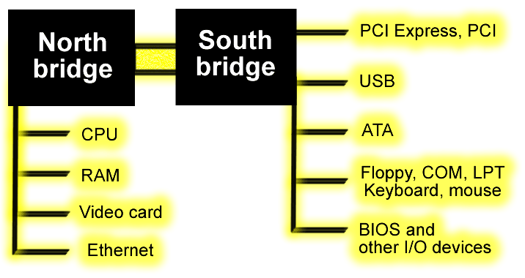

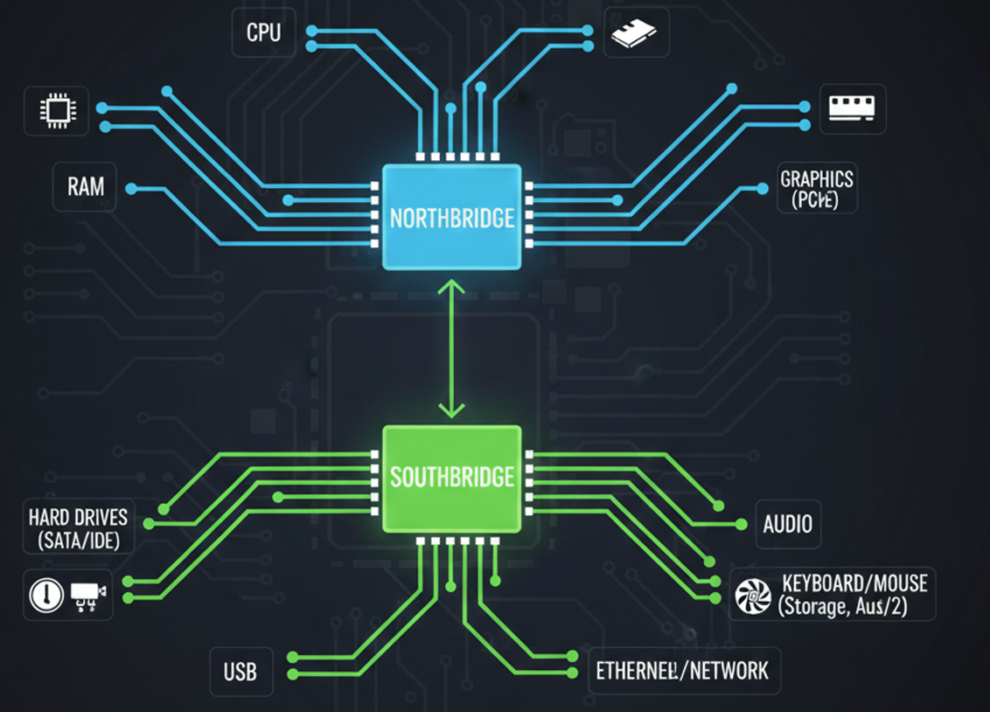

4.3 MEMORY HIERARCHY: Types of RAM & ROM

Not all memory is created equal. We categorize memory based on **Permanence** (Does it keep data when power is off?) and **Speed**.

I. ROM (Read-Only Memory)

* **Nature:** "Written in Stone."
* **Permanence:** Non-Volatile. Data stays forever.
* **Usage:** Storing the **BIOS/UEFI** firmware. This is the first code that runs when you press the power button.
* *Security Insight:* "Rootkits" that infect the BIOS are terrifying because formatting the hard drive does not fix them. They live in the ROM chip.

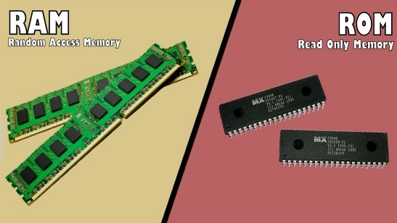 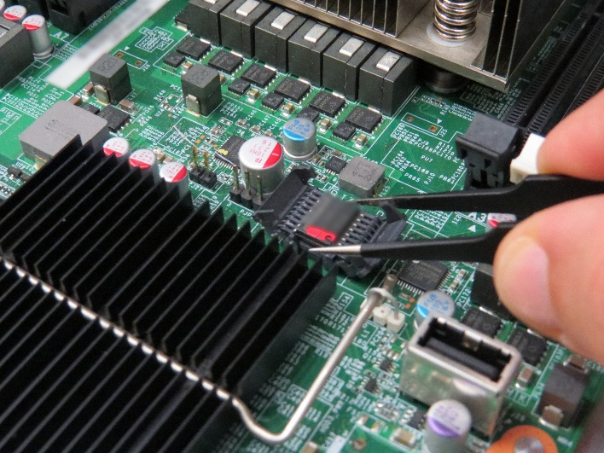

II. EPROM (Erasable Programmable ROM)

* **Nature:** "The Whiteboard."
* **Mechanism:** It can be erased, but it requires blasting the chip with distinct **Ultraviolet (UV) Light** through a small quartz window on the chip.
* **Usage:** Old embedded systems. Rarely used in PCs today (replaced by EEPROM/Flash, which can be erased via electricity).

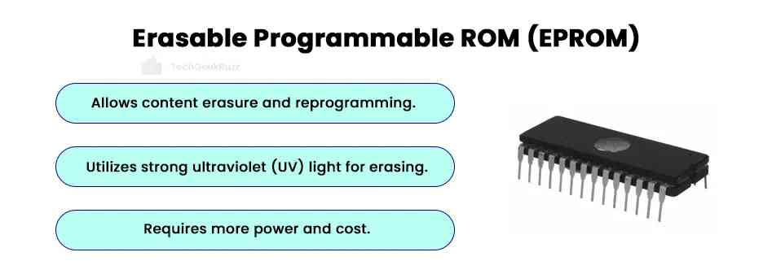

III. DRAM (Dynamic RAM)

* **Nature:** "The Leaky Bucket."
* **Mechanism:** It stores data using tiny capacitors. These capacitors leak electricity and lose the data within milliseconds.
* **The Refresh Cycle:** To keep the data alive, the memory controller must "recharge" (refresh) every row of RAM thousands of times per second.
* **Usage:** This is your **Main System Memory** (e.g., 16GB DDR4). It is cheap and dense.
* *Security Insight:* **Cold Boot Attacks.** If you freeze a DRAM stick with compressed air, the "leak" slows down. Hackers can pull the RAM out of a running laptop, freeze it, and read encryption keys from it minutes later on another machine.

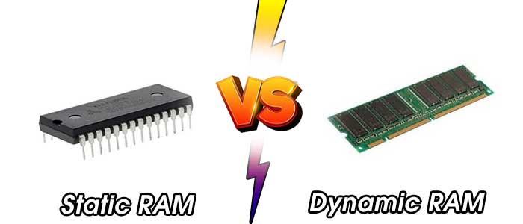

IV. SRAM (Static RAM)

* **Nature:** "The Flip-Flop."
* **Mechanism:** Uses a circuit of 6 transistors to hold a bit. It does **not** need refreshing. As long as power is on, data is rock solid.
* **Speed:** Blazingly fast. Much faster than DRAM.
* **Usage:** **CPU L1/L2/L3 Cache.** It is too expensive and bulky to use for main memory.

V. VRAM (Video RAM)

**Nature – “The Dual-Ported Artist.”**  
This memory is called *dual-ported*, which means **two devices can use it at the same time** without waiting for each other.

The **GPU writes new images (frames)** into the memory, while at the same time the **monitor reads those frames** to display them on the screen.

Because both actions happen at once, graphics stay smooth and fast with no pauses or flickering. This type of memory is mainly used in **graphics cards**.

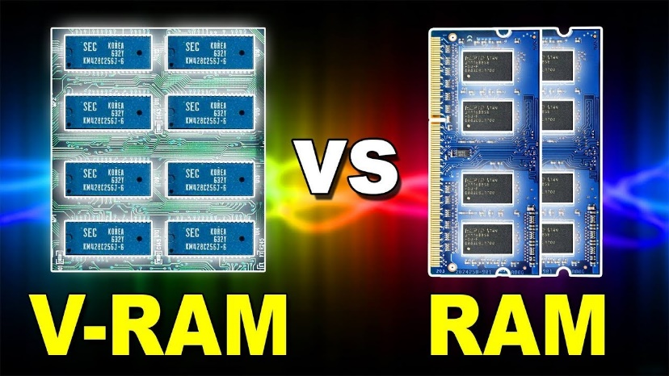

V. CMOS RAM (Complimentary Metal Oxide Semiconductor)

**CMOS RAM (Complementary Metal Oxide Semiconductor)** is like a **battery-powered notepad** on the motherboard.

It is a very small and separate piece of memory that stays alive using a **coin-cell battery (CR2032)**, even when the computer is turned off.

Its job is to store important settings that must not be lost during a power outage, such as the **system date and time** and **BIOS settings** like boot order and overclocking speeds.

A **useful trick** is that if you ever forget your **BIOS password**, removing the battery will erase the stored data and reset the settings, clearing the password.

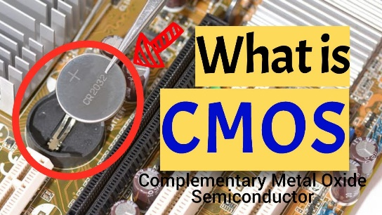 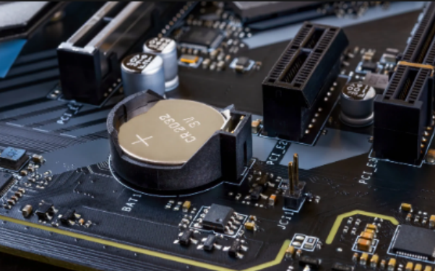

4.4 Comparison Table: Memory Types

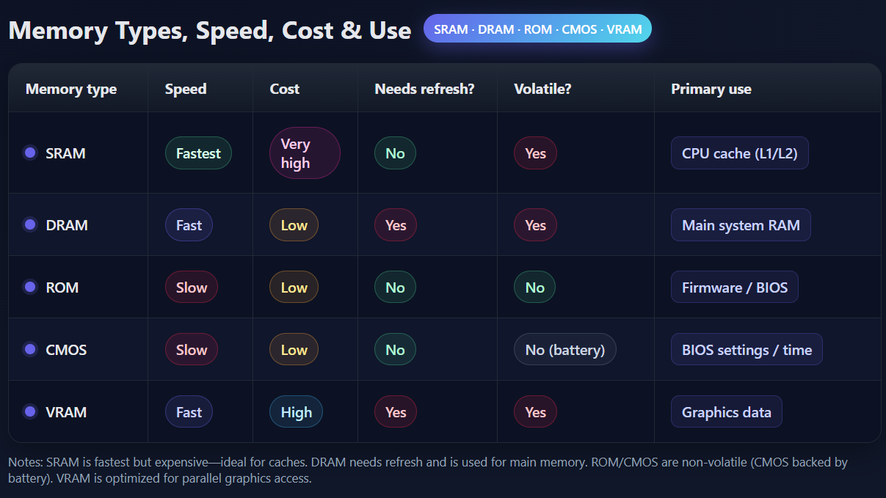

*Why can you not execute MOV AH, SIL in 64-bit mode?*

*Why is DRAM cheaper than SRAM?*

*If you turn off your computer, why does the clock not reset to 12:00?*

*What is the "Refresh" cycle in memory?*

CONNECTING THE WORLD – BUS ARCHITECTURE & I/O

Introduction: The Digital Nervous System

We have the Brain (CPU) and the Body (Motherboard). Now we need to discuss the nerves—the pathways that carry signals from the brain to the limbs (Graphics Cards, Network Cards, SSDs).

In the x86 world, this nervous system is defined by the **PCI** and **PCI Express** standards.

The PCI Bus (Peripheral Component Interconnect)

**The Legacy Standard**

Before 2004, if you opened a computer case, you would see white slots at the bottom. These were PCI slots.

* **Function:** It is a **Parallel Bus**. All devices connected to the PCI bus share the same wires.
* **The Shared Lane Problem:** Imagine a single-lane highway shared by a Ferrari (Graphics Card) and a Dump Truck (Sound Card). If the Dump Truck is moving slowly, the Ferrari is stuck behind it. All devices have to wait for the bus to be free.
* **Speed:** relatively slow by modern standards (133 MB/s).

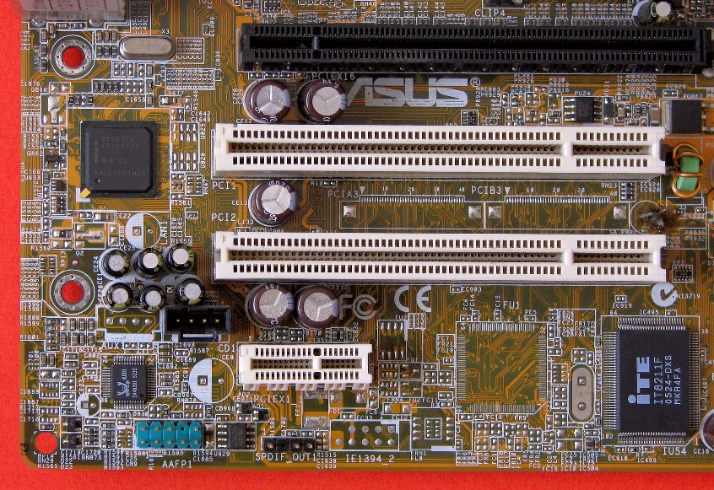

PCI EXPRESS (PCIe): The Modern Superhighway

I. The Revolution

PCI Express (PCIe) replaced the old **shared bus** design with a **direct, point-to-point serial connection** between components.

Instead of many devices fighting to use the same data path, each device gets its **own dedicated link** to the CPU or chipset.

Rather than sending many bits at once slowly (parallel), PCIe sends **one bit per lane at extremely high speed**, and multiple lanes can work together to increase performance.

Data is transferred in **small, ordered chunks**, and the receiving device confirms that each chunk was received correctly before the next one continues.

This makes PCIe faster, more reliable, and more efficient than older designs.

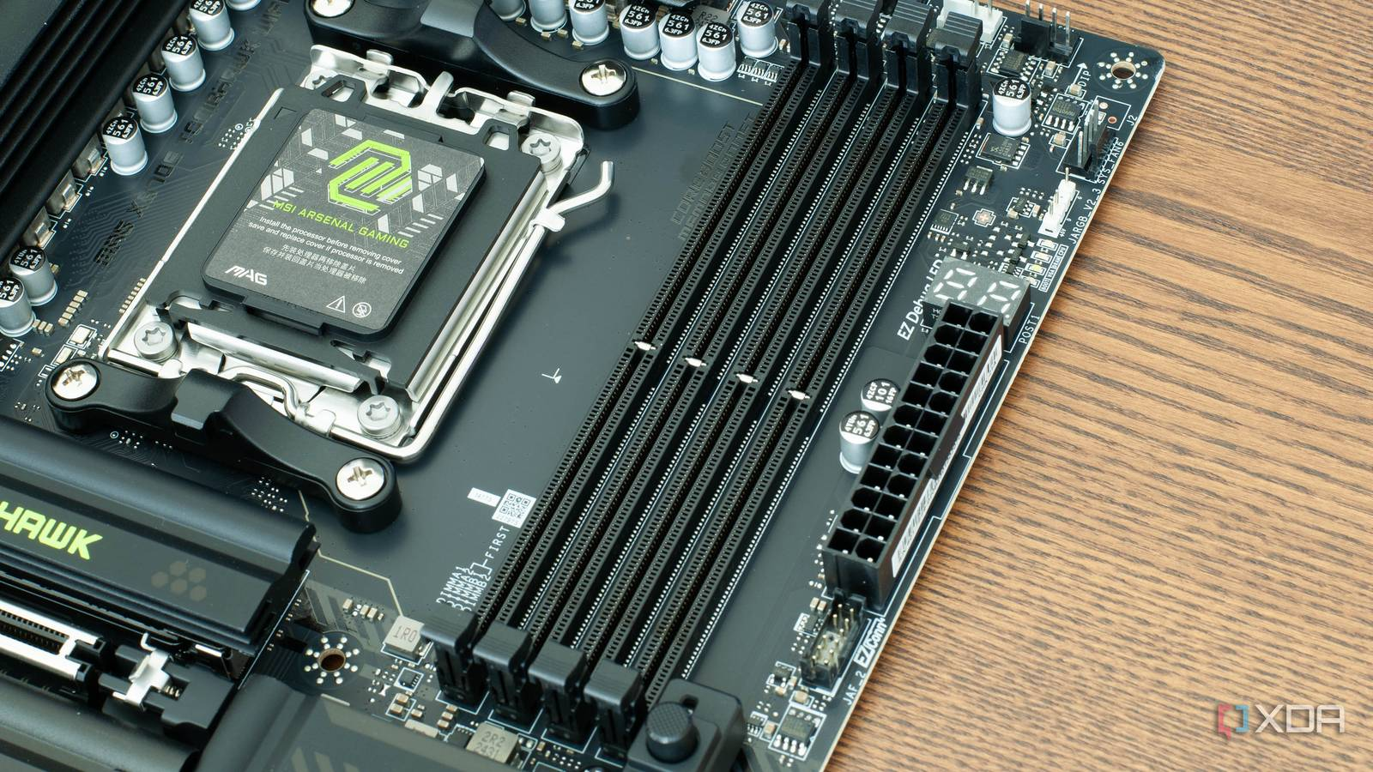

II. The Concept of Lanes

This is one of the most important ideas in modern computer hardware.

A **PCIe lane (x1)** is made of **two pairs of wires**: one set sends data (TX) and the other receives data (RX).

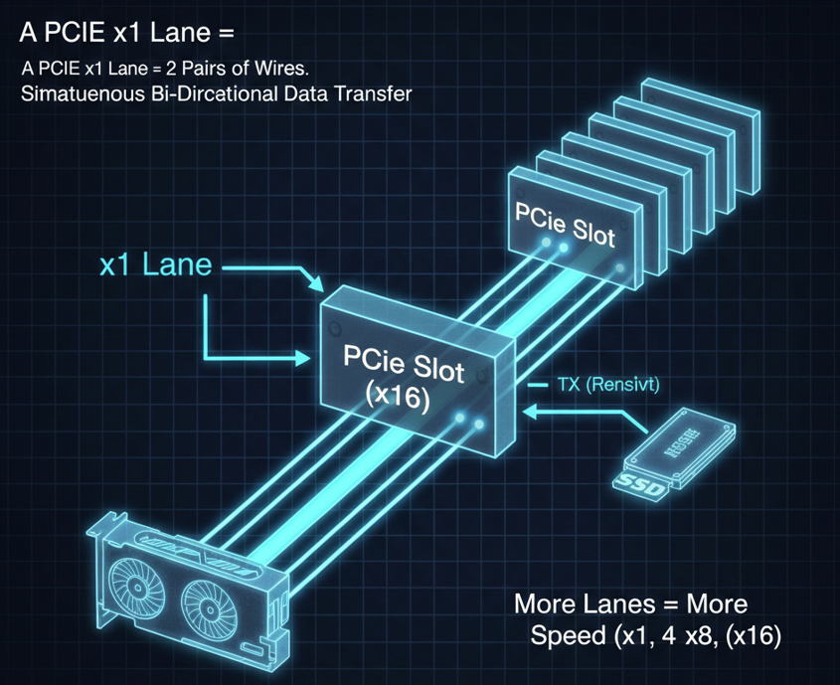

This means data can move in both directions at the same time. If a device needs more speed, PCIe simply **adds more lanes**, letting more data move at once.

For example, **x1 lanes** are enough for devices like sound cards or Wi-Fi cards, **x4 lanes** are commonly used by high-speed NVMe SSDs, and **x16 lanes** are used by graphics cards (GPUs), which need massive bandwidth.

Unlike older PCI, where all devices shared a single data path, PCIe gives each device its **own direct connection** to the CPU or chipset.

Because sending and receiving use separate wires, PCIe supports **full-duplex communication**, meaning a device can read and write at the same time.

Older PCI was **half-duplex**, so it could only send or receive data, not both at once. 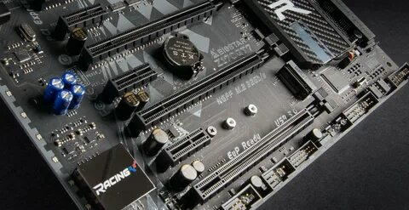

Levels Of I/O Access: The Hierarchy Of Control

When you write something simple like print("Hello"), a lot more is happening than it looks like. That single request does not go straight to the screen.

Instead, it travels down a layered chain of control, where each level passes the request to the one below it, adding more detail and precision at every step.

I. Level 3: High-Level Language Functions

This is the level most programmers live in. Languages like C++, Java, and Python operate here. When you write cout << "Hello" or System.out.println("Hello"), you are not talking to the screen or the hardware directly.

At this level, the code is portable. The same instruction can run on a Dell PC, a Mac, or a Raspberry Pi without changing how it looks. The programmer does not care how the screen works or what hardware is installed.

The compiler or interpreter takes your request and turns it into a formal request for the operating system. You are essentially saying what you want to happen, not how it should happen.

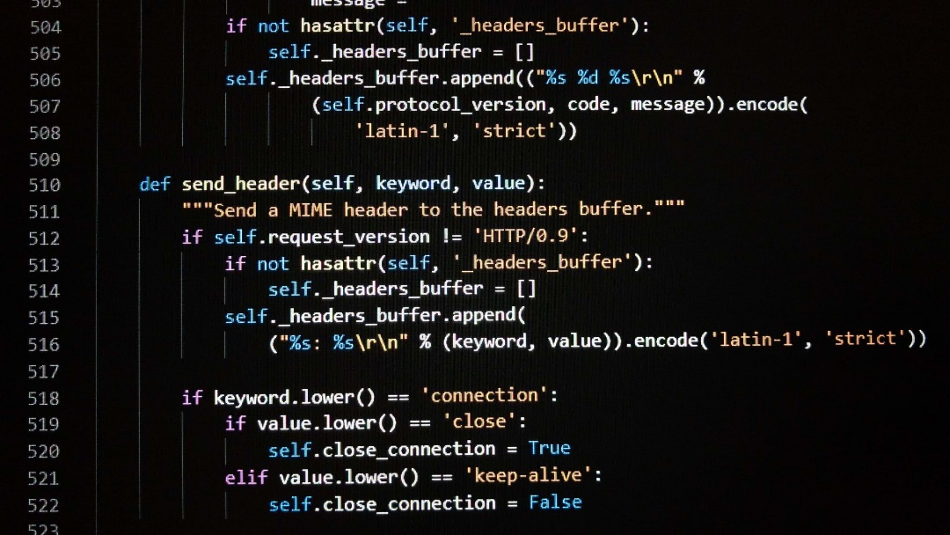

II. Level 2: Operating System API

Here, the operating system takes control. This includes things like the Windows API or Linux system calls. A function such as WriteFile is no longer portable. It is tied to a specific operating system and relies on OS-provided libraries.

At this level, the operating system checks permissions. It decides whether the program is allowed to write to the screen or access a device. If the request is allowed, the OS figures out which driver should handle it.

The programmer is still abstracted from the hardware, but now the request is no longer generic. It is shaped to fit the rules and structure of the operating system.

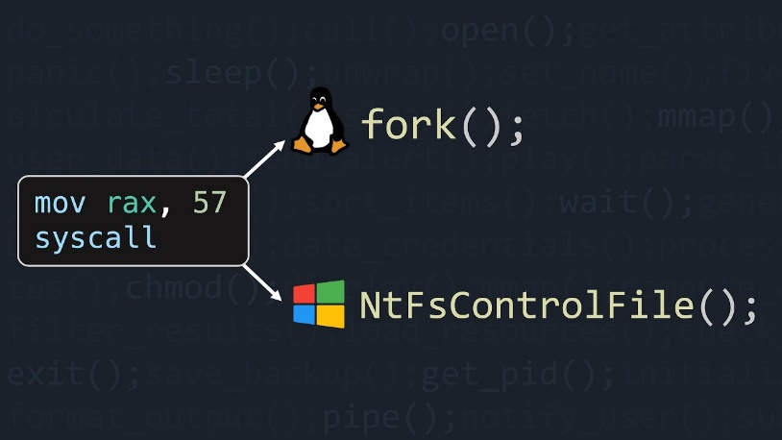

III. Level 1: Bios, UEFI, And Device Drivers

This is where the software starts to truly understand the hardware. Device drivers and firmware operate at this level. They know exactly which hardware is installed and how to control it.

For example, when a game asks the system to draw graphics, the operating system does not know how to control the GPU directly. It simply passes the request to the graphics driver. The NVIDIA driver knows which registers on the GPU control rendering, memory, and even fan speed.

At this level, instructions may involve assembly code and direct communication with hardware ports or memory-mapped registers. The code is completely hardware-specific.

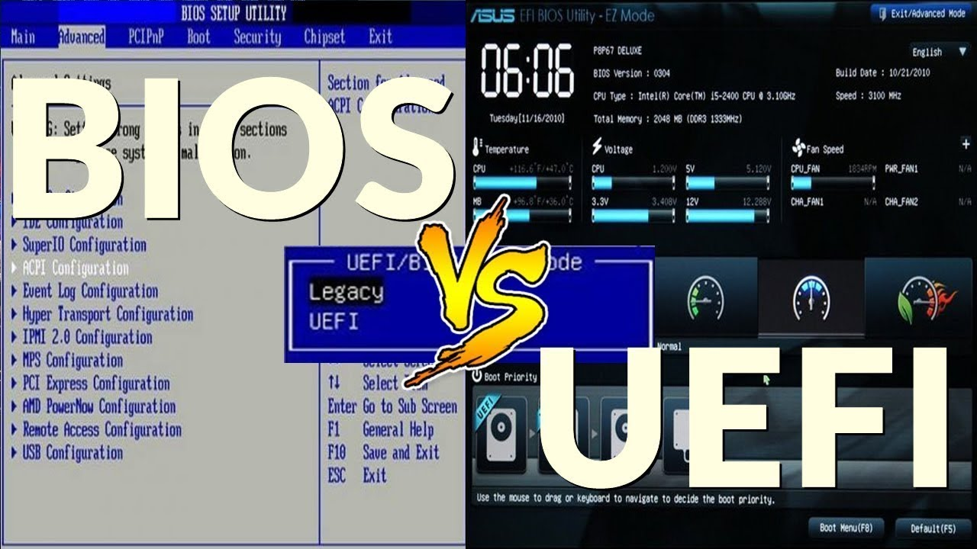

IV. Level 0: The Hardware

This is the bottom of the ladder. There is no abstraction here at all. Instructions turn into electrical signals. Voltages change on wires. Transistors flip states.

A pixel lights up on the monitor. A motor spins in a hard drive. A signal moves across the bus. This is the physical reality that all higher levels depend on.

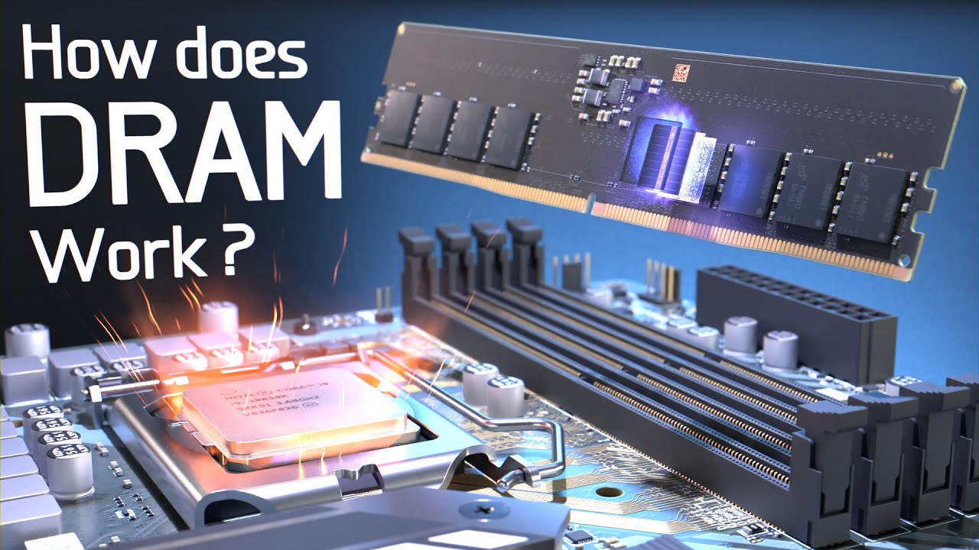

Big Idea to Remember

High-level code describes **intent**.  
The operating system enforces **rules and permissions**.  
Drivers translate requests into **hardware-specific actions**.  
Hardware executes **physical changes**.

Everything you write eventually becomes electricity doing work.

REVIEW & REVERSE ENGINEERING INSIGHT

I. Reverse Engineering Context

Why do we care about I/O levels?

**Malware Analysis:** Most malware tries to hide.

* **Level 3 hiding:** Malware won't use cout.
* **Level 2 hiding:** It might hook the Windows API (WriteFile) to intercept your keystrokes.
* **Level 1 hiding (Rootkits):** Advanced malware talks directly to the BIOS or hard drive controller, completely bypassing the OS. If you only look at the OS logs, you will never see it.

II. Summary Questions

**Why is PCIe faster than PCI if it sends 1 bit at a time instead of 32?**

*Answer:* Because the frequency (speed) of the serial connection is thousands of times faster than the old parallel bus, and it doesn't suffer from "clock skew" (signals arriving at different times).

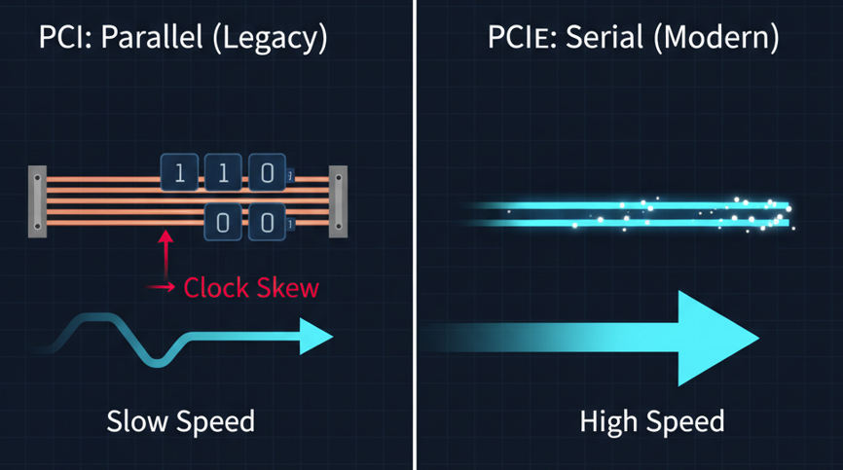

**Which I/O level provides portability across different hardware?**

*Answer:* Level 3 (High-Level Languages).

**If a game runs slowly, is it likely a bottleneck at the CPU or the PCIe Bus?**

*Answer:* It depends. If the PCIe bus is only x1 (1 lane) but the card is an RTX 4090, the data cannot get to the GPU fast enough (Bottleneck). This is why GPUs need x16 slots.

DEVICE DRIVERS: THE UNIVERSAL TRANSLATORS

The Operating System (OS) speaks one language (Generic Command), but every piece of hardware—your mouse, your printer, your graphics card—speaks a completely different, unique dialect (Hardware Specifics). If they tried to talk directly, nothing would work.

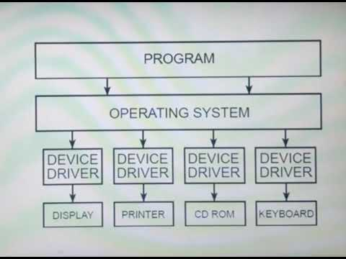

I. The Role of The Driver

A device driver is the translator in the middle. It is a specific program that allows the operating system to communicate directly with hardware devices and the system BIOS.

Here is how the translation process works:

1. **The Request:** The OS sends a generic command, like "Read data from the disk." The OS does not know *how* the disk works mechanically; it just knows it wants data.
2. **The Translation:** The device driver receives this request. It looks at the specific device it manages (e.g., a Samsung SSD vs. a Western Digital HDD).
3. **The Execution:** The driver executes specific code in the device's firmware to physically retrieve that data.

The OS asks *what* to do. The driver knows *how* to do it.

II. Installation: Getting the Translator on board

Before the OS can talk to a device, it needs the right driver. This usually happens in one of two ways:

* **Pre-Installation:** You install the driver software manually *before* plugging in the device. This is common with complex hardware like high-end printers or gaming mice.
* **Plug-and-Play (Post-Attachment):** You plug the device in first. The OS detects an electrical signal and recognizes the device's "signature" (a unique hardware ID). The OS then searches its library or the internet, locates the matching driver, and installs it automatically. 🔌



III. Case Study: The Journey Of A Character

To understand how deep this hierarchy goes, let’s track exactly what happens when you write a simple program to display the letter "A" on your screen. This is a journey from high-level code down to physical electricity.

**Step 1: The Application (Level 3)**

You write a line of code in a High-Level Language (HLL) like Python or C++. You ask the computer to print "A". At this stage, you are just expressing intent.

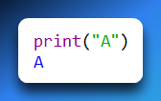

**Step 2: The Library Function (Level 3)**

Your code calls a standard library function. This function takes your text and formats it so the Operating System can understand it. It passes a "pointer" (an address in memory where "A" is stored) to the OS.

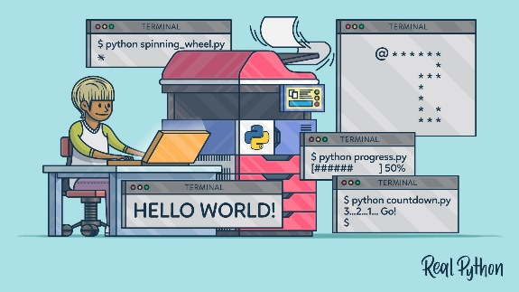

**Step 3: The Operating System (Level 2)**

The OS takes over. It cannot just "throw" the character at the screen. It uses a loop to process the string one character at a time. It identifies the ASCII code for "A" (which is 65) and determines the color it should be.

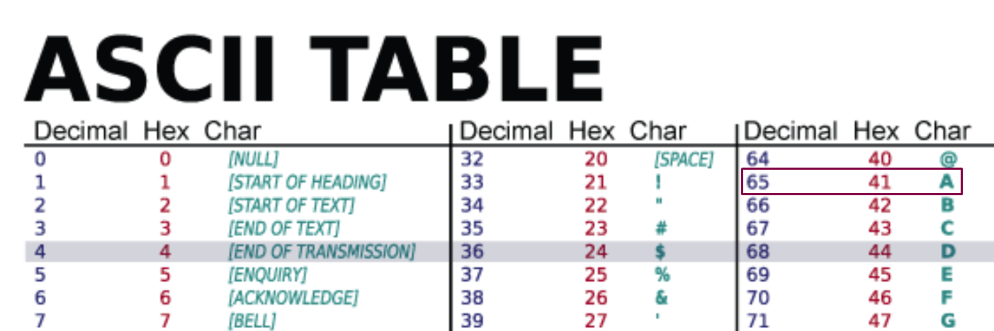

**Step 4: BIOS and The Driver (Level 1)**

The OS calls a BIOS subroutine or the video driver. This is where the logic gets visual. The driver receives the ASCII code and maps it to a "System Font." It decides which shape corresponds to "A".

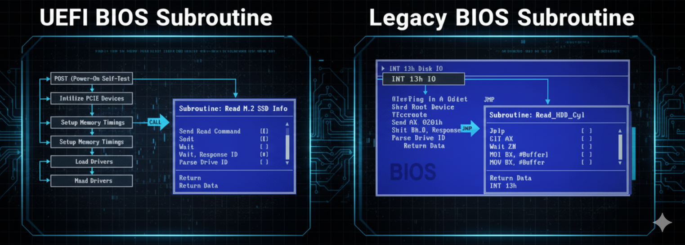

It then sends this data to a specific **Hardware Port** attached to the video controller card. This is the bridge between software and physical hardware.

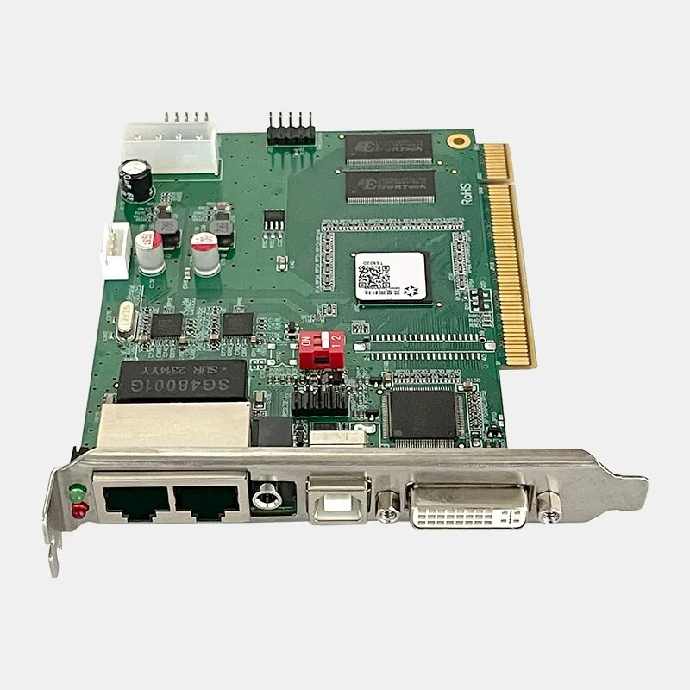

**Step 5: The Video Controller (Level 0)**

Now we are in the hardware. The video controller card receives the data. It generates timed hardware signals.

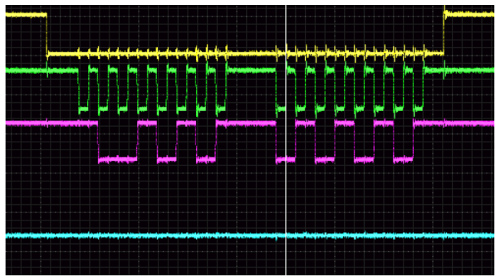

**Step 6: Raster Scanning (Level 0)**

The video card controls the monitor using Raster Scanning. This is the process of drawing the image pixel by pixel, line by line, from the top left of the screen to the bottom right, happening roughly 60 to 144 times every second. The specific pixels light up to form the shape of "A".

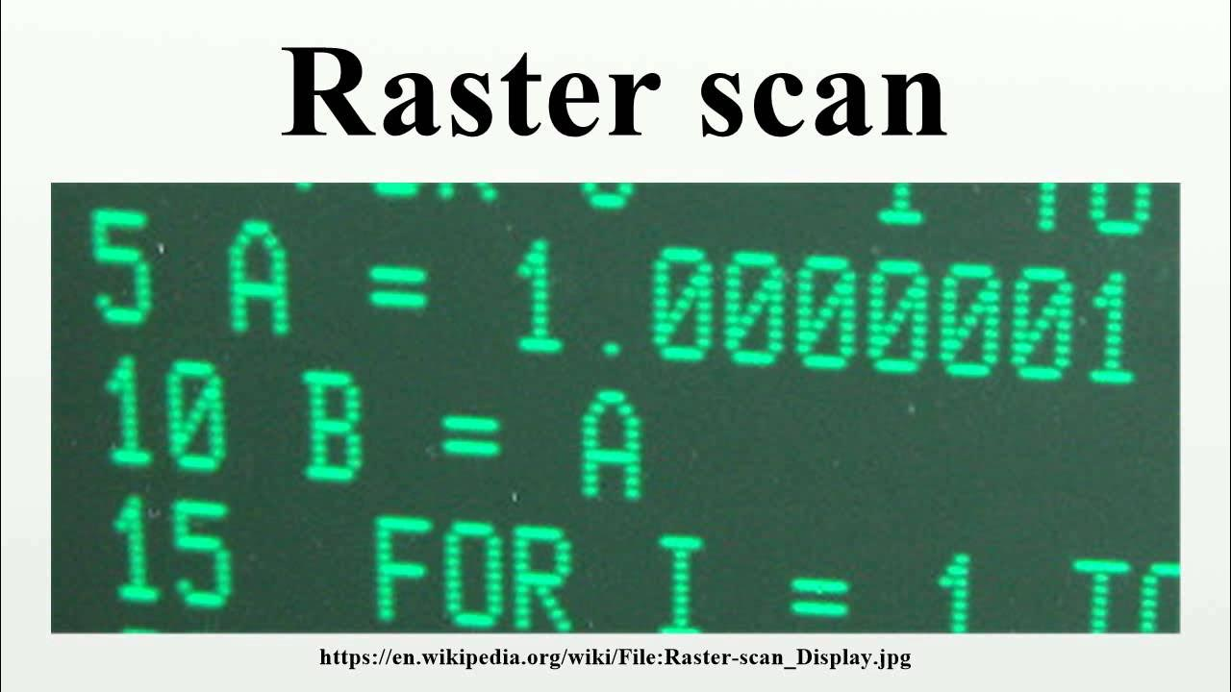

Drivers act as **translators** between the operating system and hardware. They convert **generic OS commands** into **device-specific actions** that the hardware understands.

Drivers can be installed **manually** ahead of time or **automatically** using **Plug-and-Play** when a device is connected.

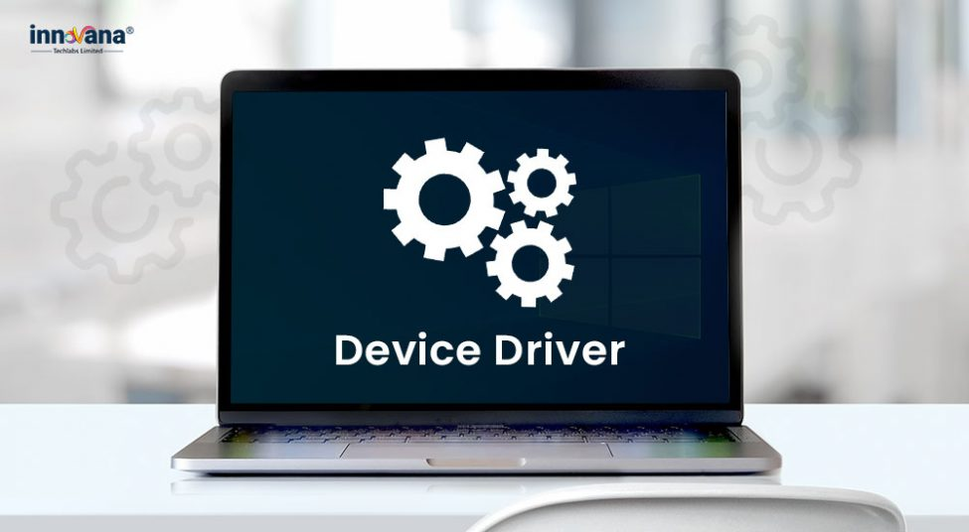

The overall flow is: **abstract software intent → operating system rules → driver translation → physical hardware action** (electric signals and light).

PROGRAMMING AT MULTIPLE LEVELS: THE POWER OF CHOICE

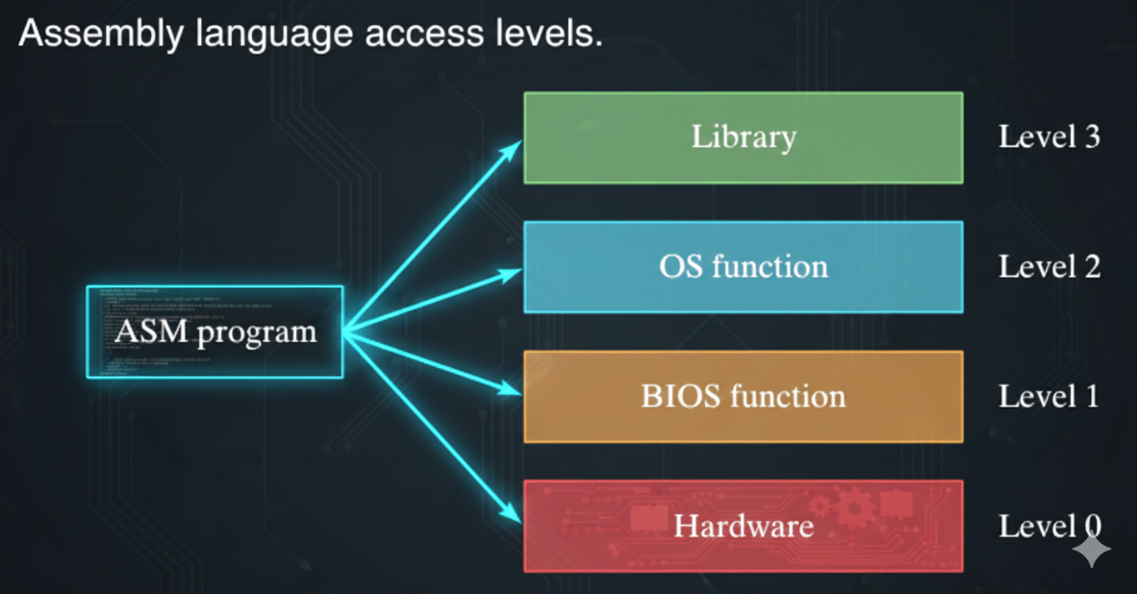

One of the superpowers of Assembly language is flexibility. Unlike high-level languages that force you to stay in the **"safe zone,"** Assembly lets you choose exactly how deep you want to dive.

You have four distinct levels of access to the computer's resources. Think of it like a building: you can stay in the penthouse, or you can go down to the basement and rewire the electricity yourself.

I. The Four Levels Of Access

**Level 3: Library Functions.** You use pre-written code libraries (like the one supplied with a textbook or standard C libraries) to handle text or files. It is easy, safe, and generic.

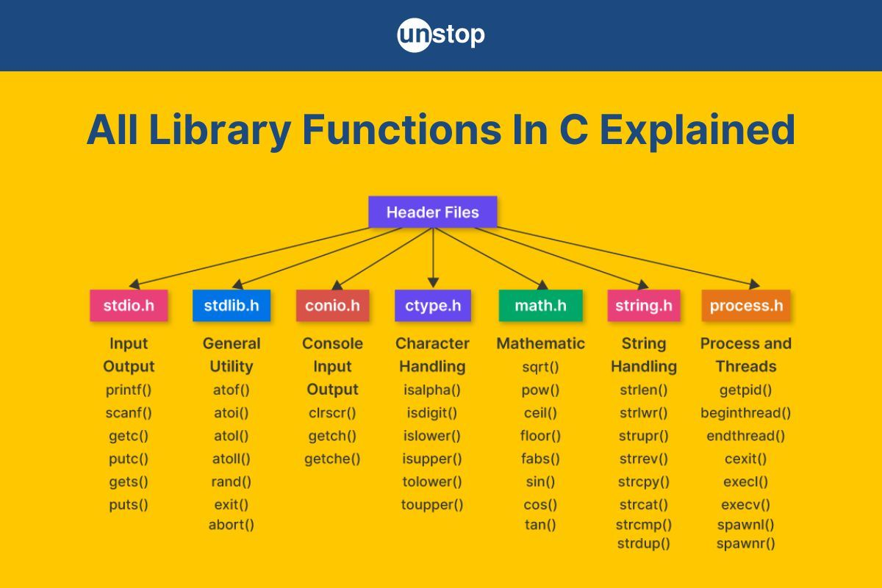

**Level 2: Operating System (OS) Functions.** You ask the OS (Windows, Linux, macOS) to do the work. If you need to draw graphics, you use the OS's generic graphics tools. You don't care about the hardware; you trust the OS to handle it.

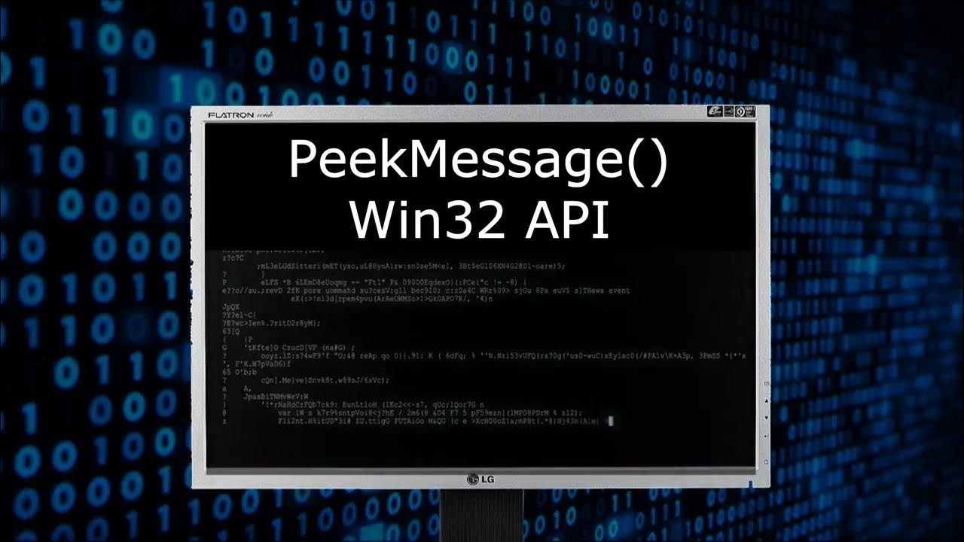

**Level 1: BIOS Functions.** You bypass the OS and talk to the BIOS. You are now controlling device-specific features like color, sound, or the keyboard directly.

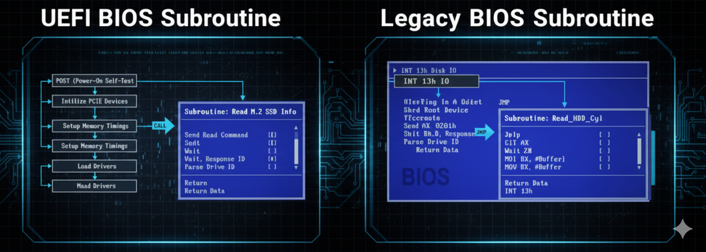

**Level 0: Hardware Ports.** Absolute control. You are sending data directly to the hardware ports. You are flipping switches on the device itself.



The Great Tradeoff: Control Vs. Portability

The deeper you go, the more power you get—but the more problems you create for yourself. The primary tradeoff is **Control versus Portability**.

I. Level 2 (The OS Level): The "Safe & Slow" Approach

* **Pros:** It is **Universal**. Code written here works on any computer running that OS. If a specific device can't do something, the OS tries to fake it (approximate the result).
* **Cons:** It is **Slower**. Every request has to pass through multiple layers of bureaucracy before it actually happens.

II. Level 1 (The BIOS Level): The "Fast & Fragile" Approach

* **Pros:** It is **Faster** than Level 2 because you skipped the OS overhead.
* **Cons:** It is **Inconsistent**. Different computers have different BIOS versions and hardware capabilities.
* *Example:* If you write code for a specific screen resolution at this level, and the user has a different monitor, your program might break. You have to write extra code just to detect what hardware the user has.

III. Level 0 (The Hardware Level): The "God Mode"

* **Pros:** **Maximum Speed.** This is how old-school "Real Mode" games worked. They took total control of the machine to squeeze every ounce of performance out of the hardware.
* **Cons:** **Zero Portability.** This code is toxic to compatibility. If you write code for a specific Sound Blaster card, it will not work on a Realtek card. You have to write custom code for *every* possible device manufacturer. 😫

REAL WORLD EXAMPLE: PLAYING A SOUND FILE 🎵

To really see the difference, imagine you want to play a .WAV music file.

**At Level 2 (OS):** You just say "Play File." You don't care if the computer has a fancy studio sound card or cheap built-in speakers. The OS handles the details.

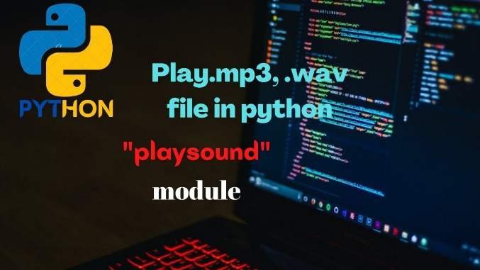

**At Level 1 (BIOS):** You have to ask the driver: "What class of sound card is this? Does it support these features?"

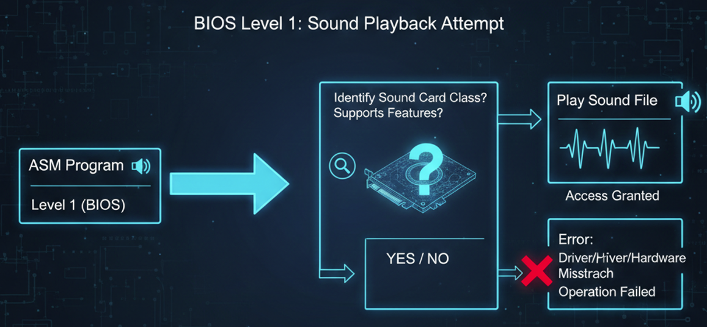

**At Level 0 (Hardware):** You have to tune your program for the specific model of the audio chip. You are manually managing the electrical signals that make the sound.

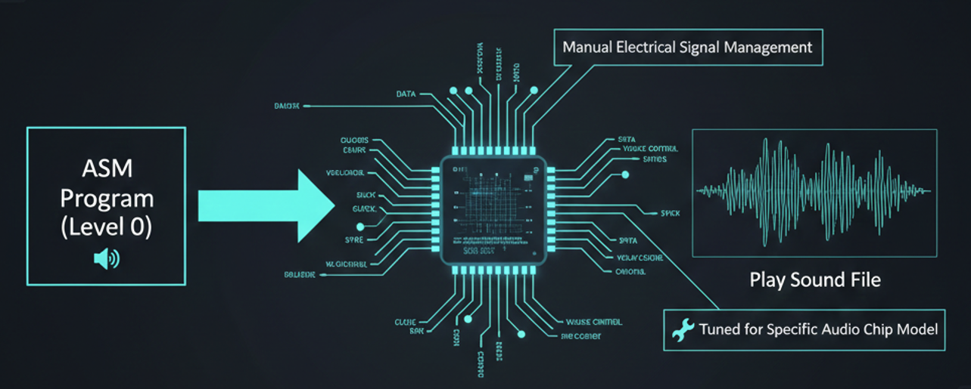

THE "NO TOUCHING" RULE IN MODERN SYSTEMS

You might ask: *If Level 0 is so fast, why don't we always use it?*

**1. Multitasking Safety**General-purpose operating systems (like Windows 10/11 or macOS) rarely let you touch Level 0 directly. Why? Because if your program takes direct control of the hardware, no other program can use it.

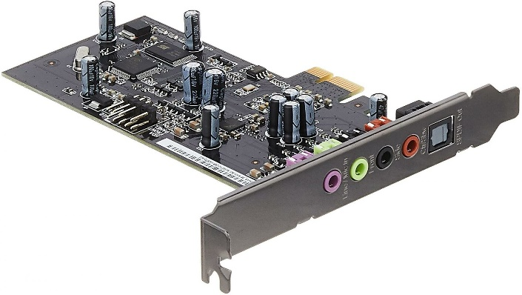

If *Spotify* grabbed the **sound card** at Level 0, *YouTube* would be silenced, and your system notifications would vanish.

The OS acts as a referee to ensure multiple programs can run at the same time without fighting over resources.

**2. Specialized Systems**Direct hardware access (Level 0) is still used in **Embedded Systems** (like the computer inside a microwave or a car engine). These systems usually only run *one* program at a time, so they don't need a referee. They need speed and efficiency, not multitasking.

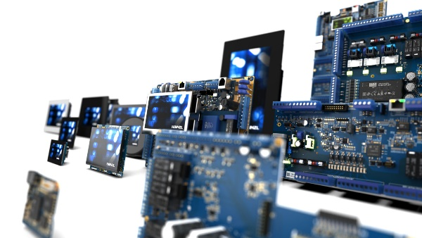 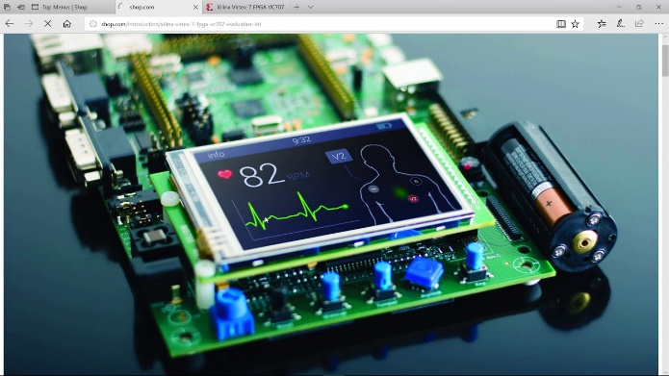

*Historical Note:* **MS-DOS** was the last major Microsoft OS that allowed this "Wild West" direct access. That is why it could only run one program at a time.

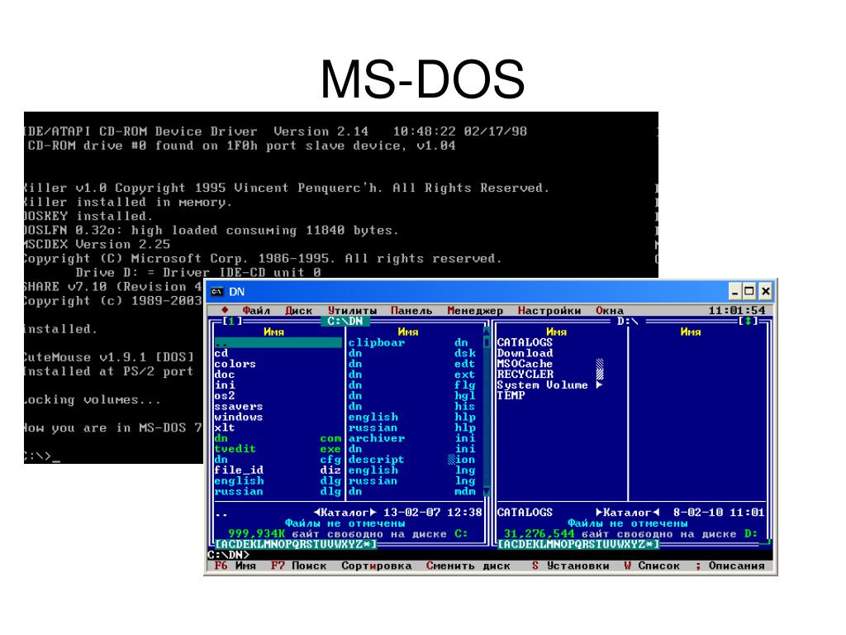

Big Idea to Remember

* **Level 3 & 2 (High):** Easy and Portable, but slower. (Generic)
* **Level 1 & 0 (Low):** Fast and Powerful, but specific to that machine. (Specific)
* **Modern OS Rule:** You are banned from Level 0 to protect system stability and multitasking.
* **Embedded Systems:** You live at Level 0 for maximum efficiency.